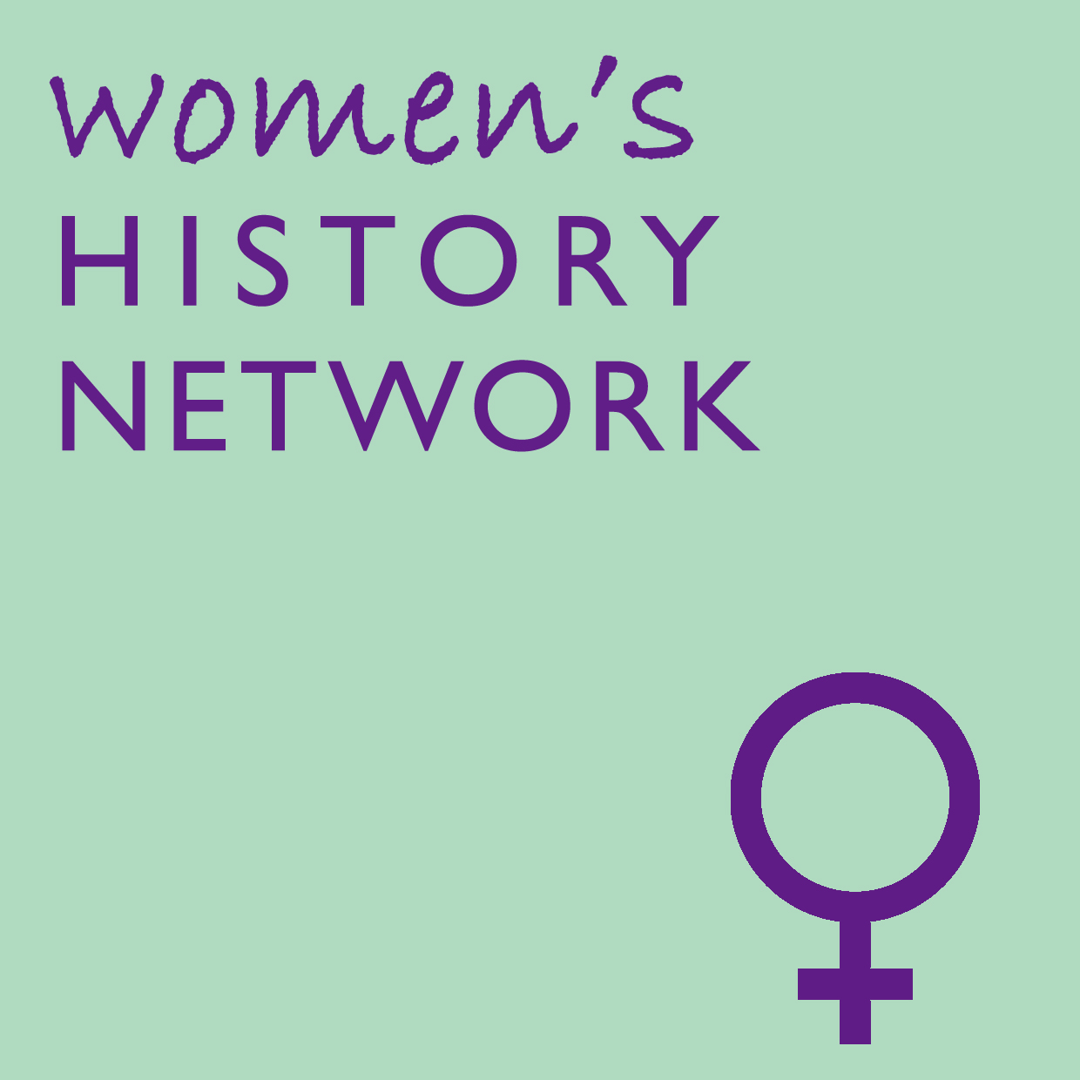 | Women’s History Network  Community History Prize 2019  sponsored by the History Press
The Women’s History Network is a national association and charity for the promotion of women’s history and the encouragement of women and men interested in women’s history. Established in 1991, the network reaches out to welcome people from any background who share a passion for women’s history.
This annual prize of £500 is awarded to the team behind a Community History Project by, about, or for women in a particular locale or community which has been completed between the 1 January 2018 and 31 May 2019.
The winners will be invited to receive their prize at the 28th Annual Women's History Network Conference at London School of Economics in September 2019.
Deadline for nominations is 31 May 2019.
We encourage submissions from projects which include a strong element of community engagement or collaboration and which communicate a sense of heritage uncovered and learning shared by participants from outside the academic or professional heritage sector.
Projects can have creative or wellbeing outcomes, as well as research outputs, but the entrants' activity must have led to the creation of something which is based on and communicates the findings of the group’s historical research, such as a production, artwork, website, documentary, pamphlet, heritage trail, book, exhibition, artefact or event.
To enter : please complete this form electronically as a Word document and send as an email attachment with two jpg images showing your project activity which can be used as part of WHN/History Press publicity in print and online to  communityhistoryprize@womenshistorynetwork.org  The Prize will be judged by a panel of representatives drawn from the Women's History Network (WHN), The History Press, heritage professionals and community historians. Photographs of all project entries will be displayed at the WHN Annual Conference. | Further supporting evidence of the project, can be sent by post. Email the prize convenor for the postal address.  This might include, for example: a copy of the book, pamphlet, website, video etc produced, photographs or video of the event, artefact or exhibition, copies of any newspaper reports, reviews or feedback on the project. Please note that we cannot undertake to return these items.  For further details the Women History Network visit - https://womenshistorynetwork.org/  For more information about the History Press visit https://www.thehistorypress.co.uk/

Project title
Brief description of the project | 50 words maximum
Date project was completed | this must be between 1 January 2018 and 31 May 2019
If project was externally funded, please tell us about the grant
Overall project budget
Group or individuals responsible for the project
Name of key contact
Email address of key contact
Phone number of key contact
Name and contact details of proposer if different from above
Please explain the aims and outcomes of the project and summarise what you did to achieve them | 1000 words maximum
How has the research been presented to the general public?  (eg book, exhibition, film, website etc. Please provide website / social media links if applicable) | 500 words maximum
What has been the legacy of your project?  How do you plan to build on it in future? | 500 words maximum
Please provide a caption for each of your two images | Image 1
 | Image 2
List of accompanying evidence provided (eg a copy of the book, pamphlet, website, video etc produced, or photographs or video of event or exhibition, copies of any newspaper reports or feedback)
Tell us about your plans for spending the prize money, should you win | 100 words maximum
Please note that the committee will only consider entries submitted by email as a Word document with two accompanying jpg images to communityhistoryprize@womenshistorynetwork.org by 31 May 2019

